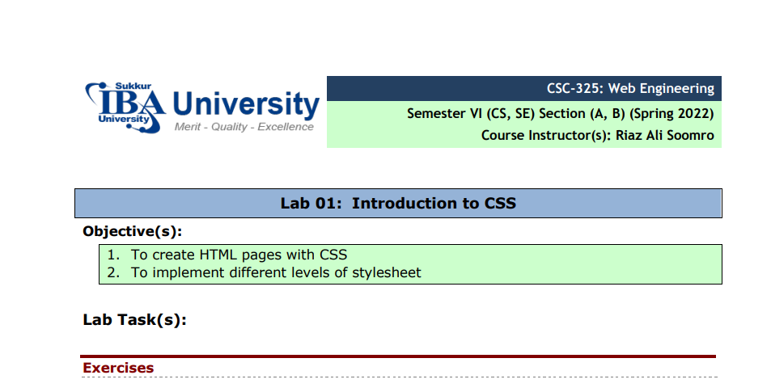
- Create the following payment form using HTML and CSS. Note: This is just a sample: Each student should apply different/unique styles
- <!DOCTYPE html>
- <HTML>
- <HEADer>
- <style>
- .container
- {
- margin-left: 30%;
- margin-right: 30%;

- }
- .form{

- background-color: lightblue;
- padding: 20px;
- border: black solid 2px;
- border-radius: 10px;

- }
- .elements{
- border-radius: 10px;
- margin-left: 6px;
- margin-right: 6px;
- padding: 5px;
- margin-bottom: 5px;
- border: black solid 2px;
- background-color:lightpink;
- align-items: center;
- align-self: center;
- align-content: center;
- text-align: center;
- word-spacing: 100px;
- position: relative;

- }
- label{
- /* width: 100%; */
- position:absolute;
- left: 20px;
- top: 10px;

- }
- input{
- width: 50%;
- padding: 5px;
- border-radius: 5px;
- margin-left:10px ;

- }
- textarea{
- width: 50%;
- border-radius: 10px;
- margin-left:10px ;

- }
- .flex-container{
- display: inline-block !important;
- /* height: 100px; */
- width: 150px !important;
- padding: 2px;
- margin-bottom: 10px;

- }
- .flex-container>input{
- width: 20px;

- }
- .but{
- text-align: right;
- margin-top: 20px;
- margin-bottom: 20px;
- width: 100%;
- margin-right: 40px;

- }
- button{
- font-size: 30px;
- background-color: lightpink;
- font-weight: bold;
- border-radius: 10px;

- }
- </style>
- </HEADer>
- <body>
- <div class="container">
- <h2>Payment Form</h2>
- <div class="form">
- <h3>Step 1: Your Details </h3>
- <div class="elements">
- <label for="name">Name</label>
- <input type="text" name="name" placeholder="Full Name">
- </div>

- <div class="elements">
- <label for="email">Email</label>
- <input type="text" name="email" placeholder="email">
- </div>

- <div class="elements">
- <label for="phone">phone</label>
- <input type="text" name="phone" placeholder="phone">
- </div>
- <h3>Step 2: Delivery Address </h3>
- <div class="elements">
- <label for="Address">Address</label>
- <textarea name="" id="" cols="20" rows="5">Adress</textarea>
- </div>
- <div class="elements">
- <label for="phone">Post-Code</label>
- <input type="text" name="phone" placeholder="postcode">
- </div>
- <div class="elements">
- <label for="phone">Country</label>
- <input type="text" name="phone" placeholder="Country">
- </div>

- <h3>Step 3: Card Details </h3>

- <div class="flex-container"><input type="radio"><img src="visa.png" alt="" width="15px"> <span>Visa</span></div>
- <div class="flex-container"><input type="radio"><img src="debit.png" alt="" width="15px"> <span>debit</span></div>
- <div class="flex-container"><input type="radio"><img src="mastercard.jpg" alt="" width="15px"> <span>mastercard</span></div>

- <div class="elements">
- <label for="phone">Card-Number</label>
- <input type="text" name="phone" placeholder="Card Number">
- </div>
- <div class="elements">
- <label for="phone">Security-Code</label>
- <input type="text" name="phone" placeholder="Card Number">
- </div>
- <div class="elements">
- <label for="phone">Name-on-card</label>
- <input type="text" name="phone" placeholder="Card Number">
- </div>

- <div class="but"> <button >BUY IT</button></div>
- </div>
- </div>
- </body>
- </HTML>

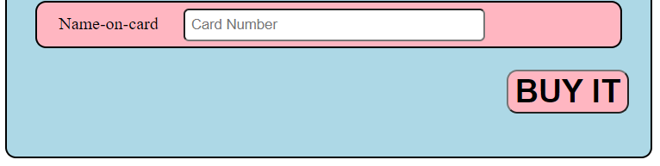
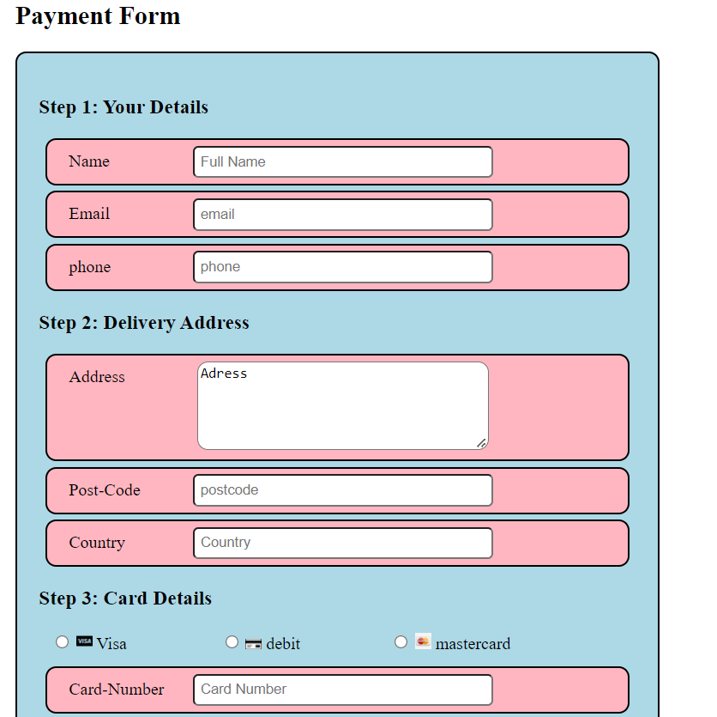

2. Design given below layout of a page using HTML5 elements and apply required CSS.

<!DOCTYPE html>
<html lang="en">
<head>
<meta charset="UTF-8">
<meta http-equiv="X-UA-Compatible" content="IE=edge">
<meta name="viewport" content="width=device-width, initial-scale=1.0">
<title>Document</title>
<!-- <link rel="stylesheet" href="style2.css"> -->
<style>
.head{
text-align: center;
padding: 1px;
/* width: 100%; */
background-color:darkblue;
color: aliceblue;
margin-left: 10px;
margin-right: 10px;

}
.flexb{
display: flex;
justify-content: space-around;
height: 550px;
}
.flexb>div{
/* background-color: #f1f1f1; */
display: inline-block;
margin-left: 2px;
margin-right: 2px;
text-align: center;
padding: 10px;

}
.foot{
text-align: center;
padding: 1px;
/* width: 100%; */
background-color:darkblue;
color: aliceblue;
margin-left: 10px;
margin-right: 10px;
}

.a{
/* background-color: aqua !important; */
width: 56%;
height: 600px;
text-align: center;
float: left;

}
.b{
background-color:lightblue !important;
width: 40%;
height: 500px;
text-align: center;
/* float: left; */
margin-top: 20px;
display: flex;
align-items: center;

}
article
{
font-size: 40px;
text-align: center;
}
table{

padding: 2px;
width: 100%;

}
tr{
background-color: aqua;
}
.b>div{
text-align: center;
margin-top: 120px;
background-color: aliceblue;
}
</style>
</head>
<body>
<div class="head">
<h3>Header</h3>
</div>
<div class="flexb">
<div class="a">
<div class="art">
<table cellspacing="10px">
<tr>
<td>
<article>
article 1
</article>

</td>
</tr>
<tr>
<td>
<article>
article 1
</article>

</td>
</tr>
<tr>
<td>
<article>
article 1
</article>

</td>
</tr>
<tr>
<td>
<article>
article 1
</article>

</td>
</tr>
<tr>
<td>
<article>
article 1
</article>

</td>
</tr>
<tr>
<td>
<article>
article 1
</article>

</td>
</tr>
<tr>
<td>
<article>
article 1
</article>

</td>
</tr>
<tr>
<td>
<article>
article 1
</article>

</td>
</tr>
<tr>
<td>
<article>
article 1
</article>

</td>
</tr>
</table>
</div>
</div>
<div class="b" style="text-align: center;">
<div>
<table >
<tr style="background-color: lightblue !important;"><td> <article>
aside
</article></td></tr>
</table>
</div>

</div>
</div>
<div class="foot">
<footer>
<h3>Footer</h3>
</footer>
</div>
</body>
</html>

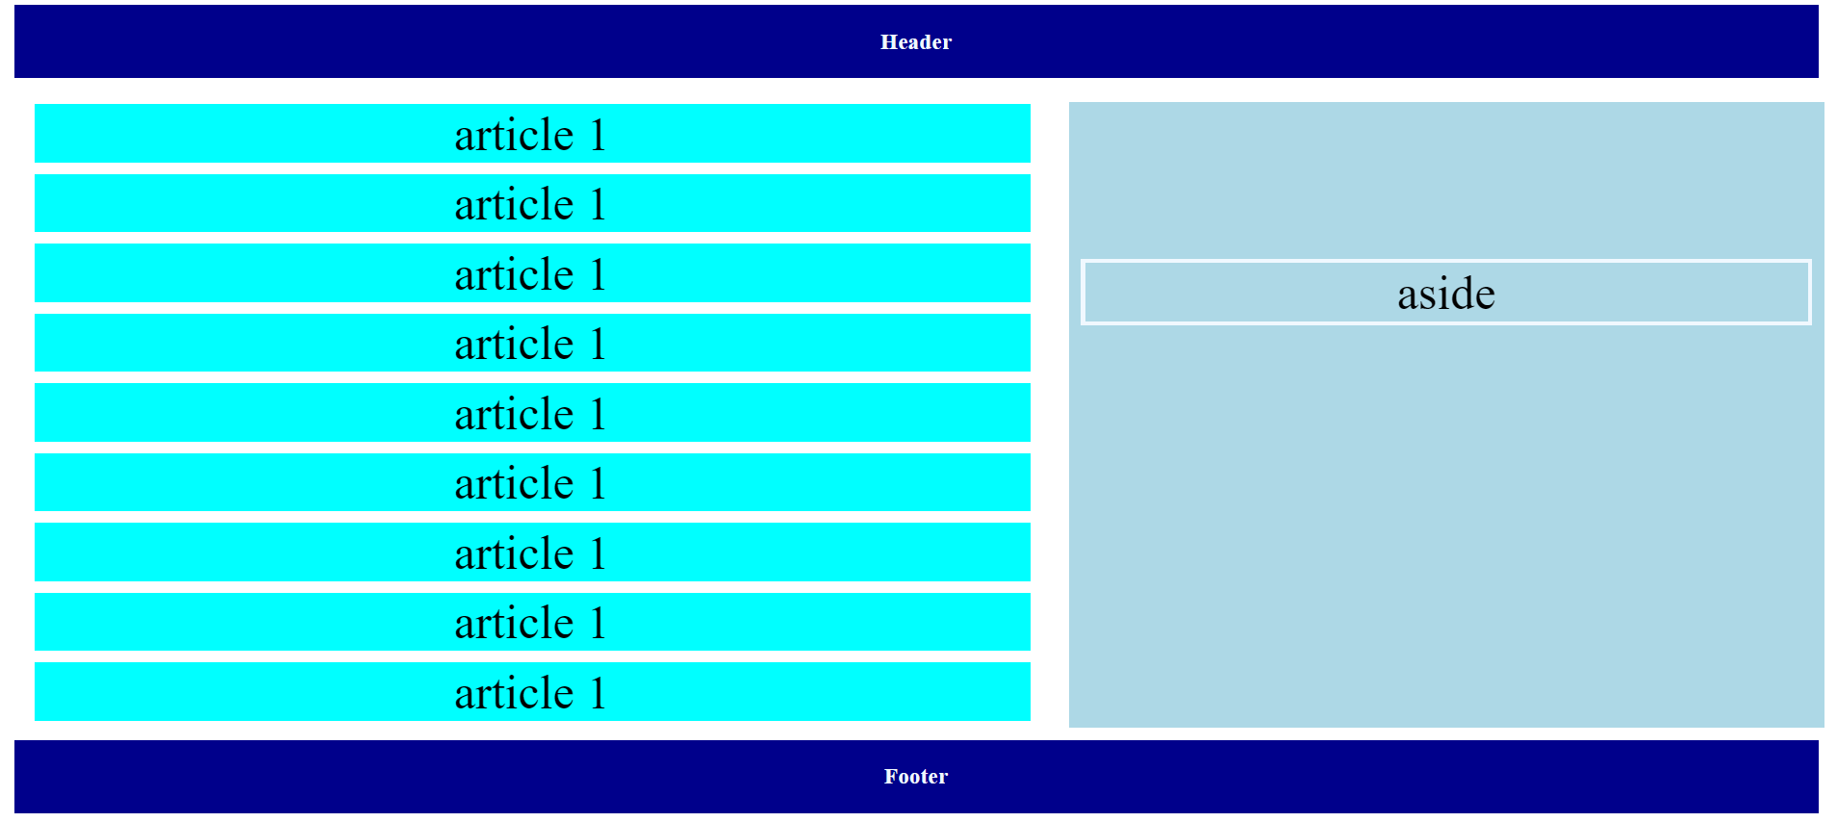

3. Create a below given page using HTML & CSS.
<!DOCTYPE html>
<html>
<head>
<!-- <link rel="stylesheet" href="style3.css"> -->
<style>
.cont{

background-color:darkgray;
width: 100%;
height: 500px;
/* display: inline-block; */

}
.cont>div{
display:inline-block;
margin-top: 10px;
}
hr{
border: 1px solid black;
}
span{
font-size: 40px;
font-family:Georgia, 'Times New Roman', Times, serif;
}

.div1

{
/* float: left; */
width: 15%;
margin-left:10px ;

}
p{
font-size: 15px;
}
table{
width: 100%;
padding: 10px;
border-spacing:0 10px ;
}

.div2{
top: 20px;
margin-left: 10px;
padding-left: 20px;
/* text-align: center; */
width: 80%;
position: fixed;
/* background-color: antiquewhite; */
}

</style>
</head>
<body>

<div class="cont">
<div class="div1">
<table cellpadding="10px">
<tr>
<td style="width: 200px;background-color: aliceblue;">Home Page</td>
<td style="background-color: chartreuse;width: 20px;"> </td>
</tr>
<tr>
<td style="width: 200px;background-color: aliceblue;">About</td>
<td style="background-color: chartreuse;width: 20px;"> </td>

</tr>
<tr>
<td style="width: 200px;background-color: aliceblue;">Contact us</td>
<td style="background-color: chartreuse;width: 20px;"> </td>
</tr>
<tr>
<td style="width: 200px;background-color: aliceblue;">Others</td>
<td style="background-color: chartreuse;width: 20px;"> </td>
</tr>

</table>
</div>
<div class="div2">
<h1>My First Page STyles With CSS</h1>
<h3>WelCome to My Page</h3>
<p>
Lorem ipsum dolor sit amet consectetur adipisicing elit. Reiciendis, ullam eum? Repellat facilis nisi numquam. Quasi magni voluptatibus minus nesciunt quis aliquid vero nam, sunt laborum? Consectetur ratione quidem repudiandae dolores mollitia laborum blanditiis cumque eius expedita dolore? Delectus quam velit accusamus exercitationem, voluptas autem inventore blanditiis quibusdam architecto, beatae recusandae. Architecto iste, consequuntur praesentium neque maiores quia corporis reiciendis cum hic dolorum provident, eveniet amet. Consequatur nostrum officiis rerum perspiciatis consectetur, dolorum quisquam velit temporibus illum, atque quibusdam vitae sunt rem eos? Ratione, dignissimos consectetur, dolores harum praesentium ipsam optio, voluptates dolorem tempora sunt commodi tempore et ipsa sed!
<br><br>
Lorem ipsum dolor sit amet consectetur adipisicing elit. Dolore maiores voluptates incidunt eligendi eius possimus temporibus ratione illum repellat ad molestias obcaecati nostrum distinctio quas, enim doloremque cupiditate officia omnis laborum reprehenderit quae dolor. Quia, fuga nemo. Dignissimos qui sint provident veniam ipsam ullam, esse doloremque delectus dolore quasi unde adipisci obcaecati quos! Atque veritatis totam possimus, obcaecati ullam amet excepturi nam aliquid saepe delectus optio facere, reiciendis nisi fuga! Iste repellat, atque deleniti, optio velit ratione nulla illum suscipit sapiente, illo fugiat? Dignissimos sint excepturi quas? In voluptate, est natus nobis, facere ducimus sit esse similique autem nisi asperiores!
</p>
<br>
<br><br>
<br>

<hr>
<span>22 Feb 2022</span>
<br>
<br>
</div>
</div>

</body>
</html>

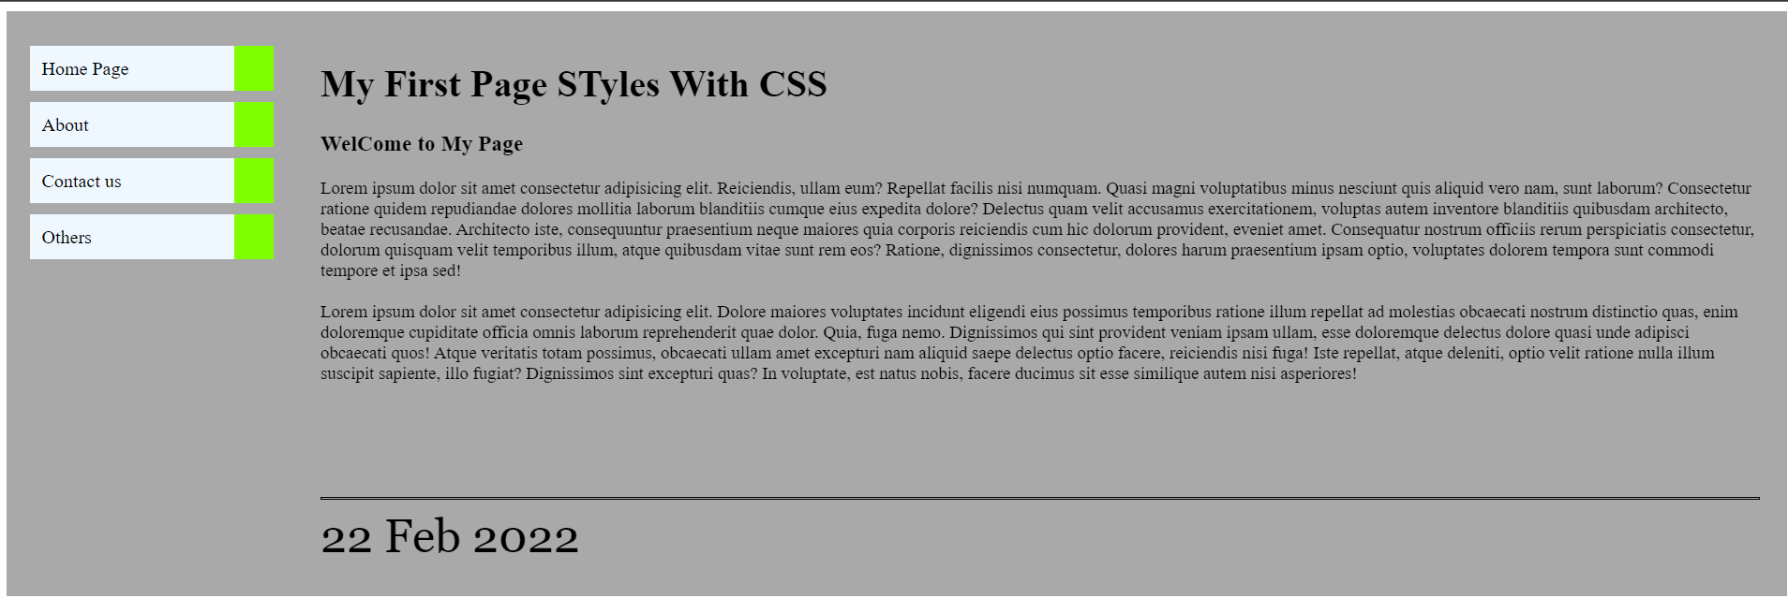

4. . Design a multiple webpage including html & CSS. Include all the CSS properties of text, border font etc. The following navigation tabs must be added:
(Use external level Style sheet) • Home (Give info about what your website is about)
• Information (Include the detailed information related to the particular technology)
• Gallery (Include images and Videos of technology)
• About (Give the information about yourself)
INDEX PAGE
<!DOCTYPE html>
<html>
<head>
<link rel="stylesheet" href="style4.css">
</head>
<body>
<div class="main">
<div class="navbar">

</div>
<div class="icon">
<a href="index.html"> <h2 class="logo">MyWebSite</h2></a>

</div>
<div class="menu">
<ul>
<li><a href="Home.html">Home</a></li>
<li><a href="About.html">About</a></li>
<li><a href="Info.html">Info</a></li>
<li><a href="Gallery.html">Gallery</a></li>

</ul>
</div>
<div class="paragraph">

<p>
Lorem ipsum dolor sit, amet consectetur adipisicing elit. Libero a porro rem error eveniet. Cupiditate harum nam, vero tempora optio cum obcaecati debitis officia a aliquid totam explicabo. Rerum, quidem.
</p>
<br>
<p>
Lorem ipsum dolor sit amet consectetur adipisicing elit. Quos libero, tempora repellendus, repudiandae earum velit enim officia cum optio vel quo illum minima sed beatae eaque sunt accusantium deserunt ducimus.
Lorem ipsum dolor sit amet, consectetur adipisicing elit. Tempore, quas reprehenderit veritatis libero odio vitae cupiditate voluptates ut nam? Suscipit dicta perferendis odit illum exercitationem. Corporis maiores consequuntur ab eligendi.
Lorem ipsum dolor sit, amet consectetur adipisicing elit. Autem recusandae, amet veritatis modi ab cumque id quidem corrupti officiis voluptate dignissimos ea nisi fuga aliquam dolore optio molestiae possimus <corporis class="lorem"></corporis>
</p>
</div>
</div>

</body>
</html>

HOME PAGE
<!DOCTYPE html>
<html>
<head>
<link rel="stylesheet" href="style4.css">
</head>
<body>
<div class="main">
<div class="navbar">

</div>
<div class="icon">
<a href="index.html"> <h2 class="logo">MyWebSite</h2></a>

</div>
<div class="menu">
<ul>
<li><a href="Home.html">Home</a></li>
<li><a href="About.html">About</a></li>
<li><a href="Info.html">Info</a></li>
<li><a href="Gallery.html">Gallery</a></li>

</ul>
</div>
<div class="paragraph">

<p>
This is Home Page.
</p>
<br>
<p>
Lorem ipsum, dolor sit amet consectetur adipisicing elit. Sequi, ipsam quos in accusamus rerum delectus assumenda cupiditate sunt consequuntur atque inventore error ipsa tempora natus? Ducimus voluptates explicabo voluptas omnis!
</p>
</div>
</div>

</body>
</html>

INFO PAGE
<!DOCTYPE html>
<html>
<head>
<link rel="stylesheet" href="style4.css">
</head>
<body>
<div class="main">
<div class="navbar">

</div>
<div class="icon">
<a href="index.html"> <h2 class="logo">MyWebSite</h2></a>

</div>
<div class="menu">
<ul>
<li><a href="Home.html">Home</a></li>
<li><a href="About.html">About</a></li>
<li><a href="Info.html">Info</a></li>
<li><a href="Gallery.html">Gallery</a></li>

</ul>
</div>
<div class="paragraph">

<p>
This is Information Page.
</p>
<br>
<p>
Lorem ipsum, dolor sit amet consectetur adipisicing elit. Sequi, ipsam quos in accusamus rerum delectus assumenda cupiditate sunt consequuntur atque inventore error ipsa tempora natus? Ducimus voluptates explicabo voluptas omnis!
</p>
</div>
</div>

</body>
</html>

Gallery PAge
<!DOCTYPE html>
<html>
<head>
<link rel="stylesheet" href="style4.css">
</head>
<body>
<div class="main">
<div class="navbar">

</div>
<div class="icon">
<a href="index.html"> <h2 class="logo">MyWebSite</h2></a>

</div>
<div class="menu">
<ul>
<li><a href="Home.html">Home</a></li>
<li><a href="About.html">About</a></li>
<li><a href="Info.html">Info</a></li>
<li><a href="Gallery.html">Gallery</a></li>

</ul>
</div>
<div class="paragraph" style="width: 100%;">

<p>
This is Gallery.
</p>
<br>
<p>
<iframe width="400" height="315"
src="https://www.youtube.com/embed/tgbNymZ7vqY">
</iframe>
<iframe width="400" height="315"
src="https://www.youtube.com/embed/tgbNymZ7vqY">
</iframe>
<iframe width="400" height="315"
src="https://www.youtube.com/embed/tgbNymZ7vqY">
</iframe>
</p>
</div>
</div>

</body>
</html>

ABOUT PAGE
<!DOCTYPE html>
<html>
<head>
<link rel="stylesheet" href="style4.css">
</head>
<body>
<div class="main">
<div class="navbar">

</div>
<div class="icon">
<a href="index.html"> <h2 class="logo">MyWebSite</h2></a>

</div>
<div class="menu">
<ul>
<li><a href="Home.html">Home</a></li>
<li><a href="About.html">About</a></li>
<li><a href="Info.html">Info</a></li>
<li><a href="Gallery.html">Gallery</a></li>

</ul>
</div>
<div class="paragraph">

<p>
This is About.
</p>
<br>
<p>
Lorem ipsum, dolor sit amet consectetur adipisicing elit. Sequi, ipsam quos in accusamus rerum delectus assumenda cupiditate sunt consequuntur atque inventore error ipsa tempora natus? Ducimus voluptates explicabo voluptas omnis!
</p>
</div>
</div>

</body>
</html>

INFO PAGE
<!DOCTYPE html>
<html>
<head>
<link rel="stylesheet" href="style4.css">
</head>
<body>
<div class="main">
<div class="navbar">

</div>
<div class="icon">
<a href="index.html"> <h2 class="logo">MyWebSite</h2></a>

</div>
<div class="menu">
<ul>
<li><a href="Home.html">Home</a></li>
<li><a href="About.html">About</a></li>
<li><a href="Info.html">Info</a></li>
<li><a href="Gallery.html">Gallery</a></li>

</ul>
</div>
<div class="paragraph">

<p>
This is Information Page.
</p>
<br>
<p>
Lorem ipsum, dolor sit amet consectetur adipisicing elit. Sequi, ipsam quos in accusamus rerum delectus assumenda cupiditate sunt consequuntur atque inventore error ipsa tempora natus? Ducimus voluptates explicabo voluptas omnis!
</p>
</div>
</div>

</body>
</html>

STYLE SHEET
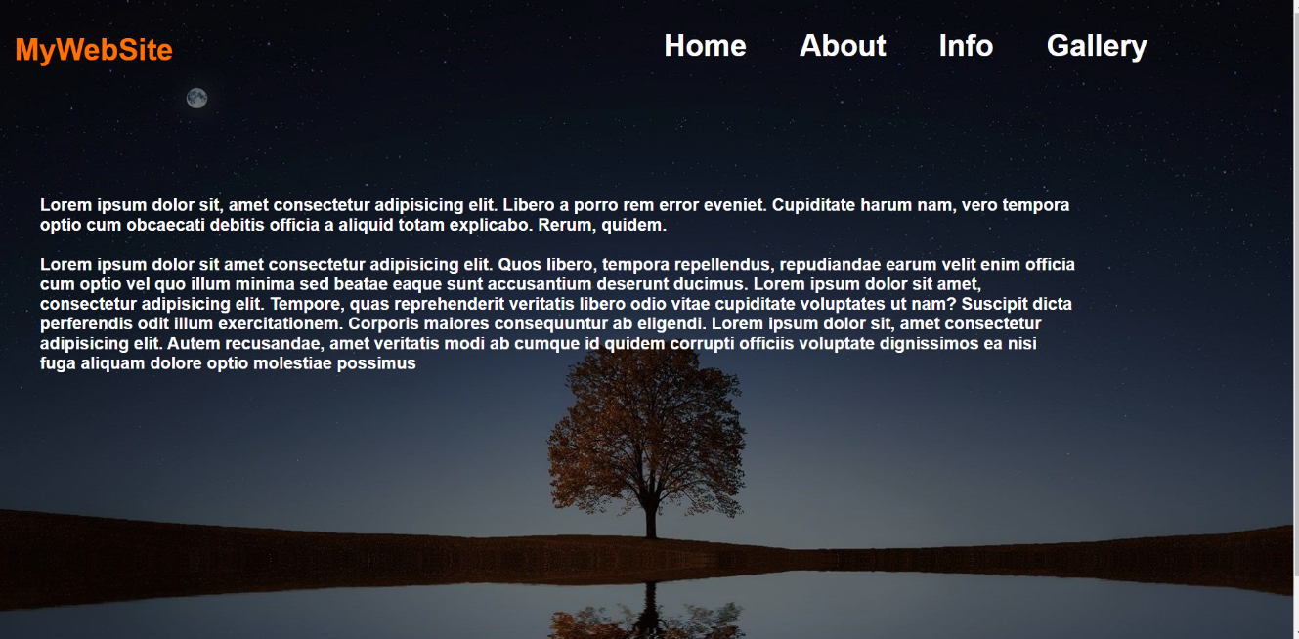
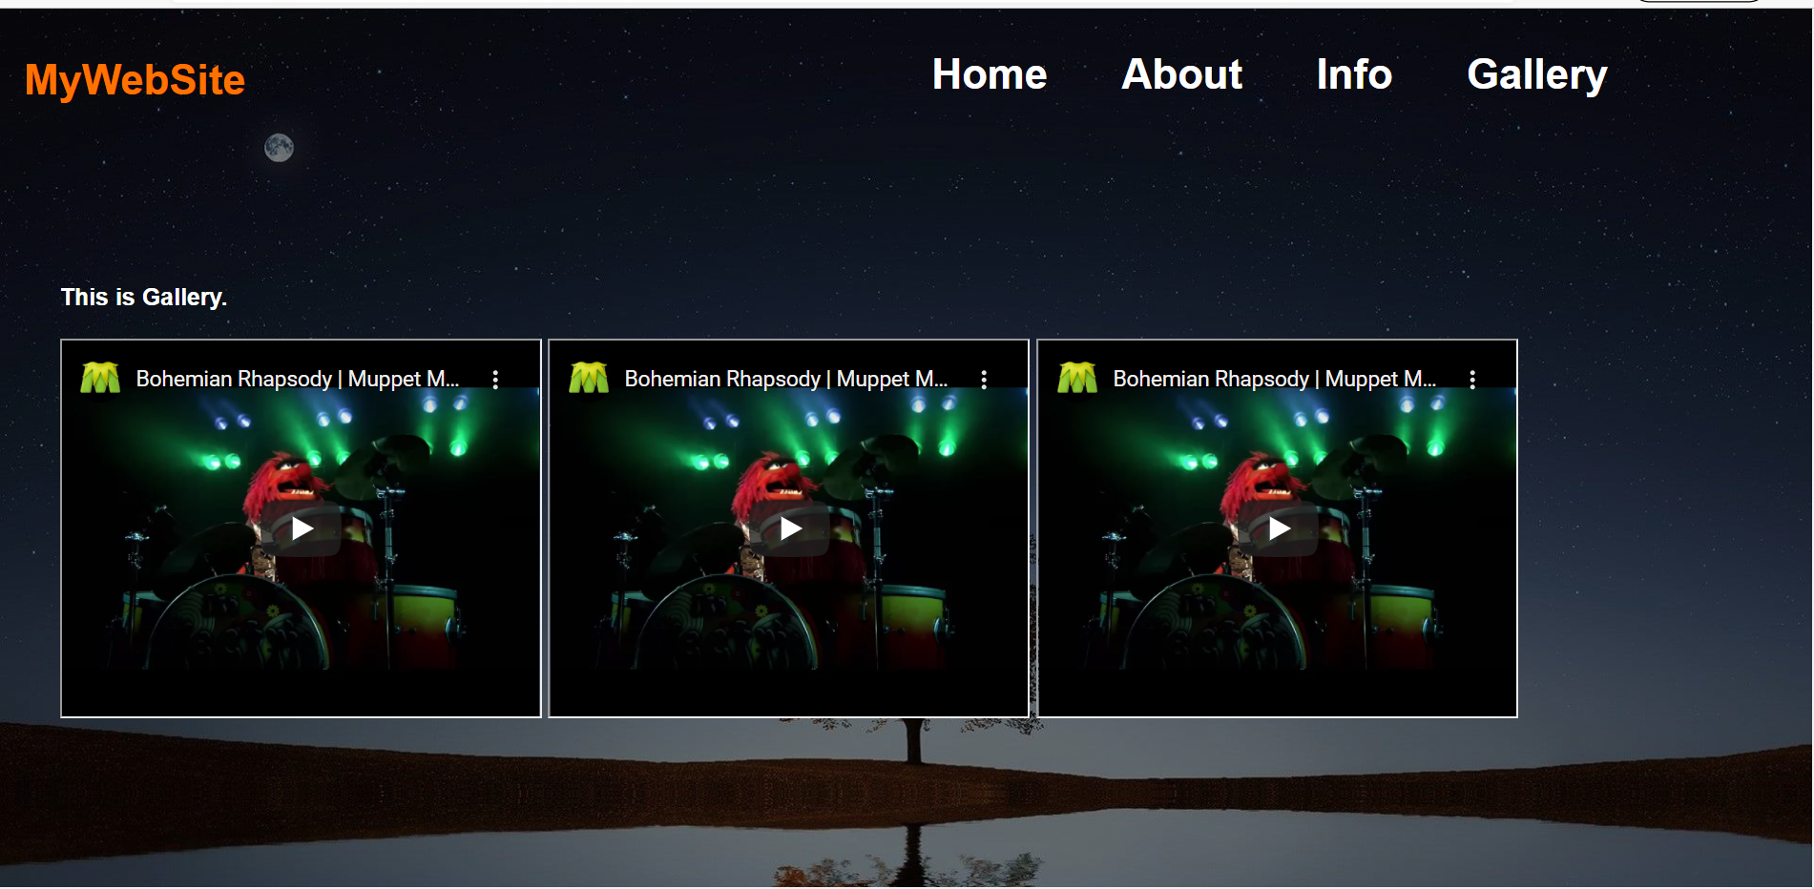

5: Create the following quiz design in HTML & CSS.
<!DOCTYPE html>
<html>
<head>
<!-- <link rel="stylesheet" href="style5.css"> -->
<style>
.main{
width: 500px;
height: 540px;
background-color: blue;
position: absolute;
margin-left: 500px;
}
.row-1{
width: 460px;
height: 50px;
margin-top: 10px;
margin-left: 20px;
background-color: white;
}
.col-1{
width: 300px;
height: 10px;
margin-left: 10px;
float: left;
}
hr{
border-width: 0.5px;
}
.t{
background-color: black;
color: white;
height: 40px;
margin-left: 85px;
position: absolute;
width: 30px;
}

.col-2{

margin-top: 10px;
border-radius: 5px;
margin-right: 10px;
width: 140px;
height: 50px;
font-weight: bold;
background-color: lightblue;
float: right;
display: flex;
justify-content: space-between;

}
.row-2{
width: 440px;
height: 445px;
padding: 10px;
margin-right: 10px;
margin-left: 20px;
background-color: white;
}
.tit{
font-size: 25px;
font-weight: bold;

}
.headings{
margin: 20px;
font-size: large;
}
tr{
outline-color: black;
outline-width: 1px;
border-width: 2px;
border-radius: 5px;
}

td{
border-radius: 10px;
border-width: 2px;
padding: 10px;
width: 400px;
outline-color: black;
outline-width: 1px;
}
.con{
display: flex;
justify-content: space-between;
}
.foot{
display: flex;
justify-content: space-around;
width: 440;
}
.ques{
margin-top: 2px;

}
.but
{
float: right;
}
button{
background-color: blue;
color: white;
font-size: 20px;
padding: 10px;
border-radius: 10px;
font-family:'Franklin Gothic Medium', 'Arial Narrow', Arial, sans-serif;
}
</style>
</head>
<body>
<div class="main">
<div class="row-1">
<div class="col-1">
<h3>Awesome Quiz Application</h3>
</div>
<div class="col-2">
<div class="time">
<h3>Time Left</h3>
</div>
<div class="t"><h3> 08</h3></div>
</div>

</div>

<div class="row-2">
<hr>
<div class="tit">
1. What Does HTML Stand for
</div>
<div class="headings">
<table cellspacing="25px">
<tr style="background-color: lightgrey;">
<td>
Hyper Text PreProcessor
</td>
</tr>
<tr style="background-color: lightgreen;">
<td>
<div class="con">
<div class="text">Hyper Text MarkUp Langauge</div>
<div class="im"><img src="check.png" width="20px" height="20px" alt=""></div>
</div>

</td>
</tr>
<tr style="background-color: lightcoral;">
<td>
<div class="con">
<div class="text">Hyper Text Multiple Langauge</div>
<div class="im"><img src="cross.png" width="20px" height="20px" alt=""></div>
</div>
</td>
</tr>
<tr style="background-color: lightgrey;">
<td>
Hyper Tool MultiLanguage
</td>
</tr>
</table>

</div>
<div class="foot">
<div class="ques">
<h3>1 of 5 Questions</h3>
</div>
<div class="but">
<button>Next Que</button>
</div>
</div>
</div>

</div>

</body>
</html>

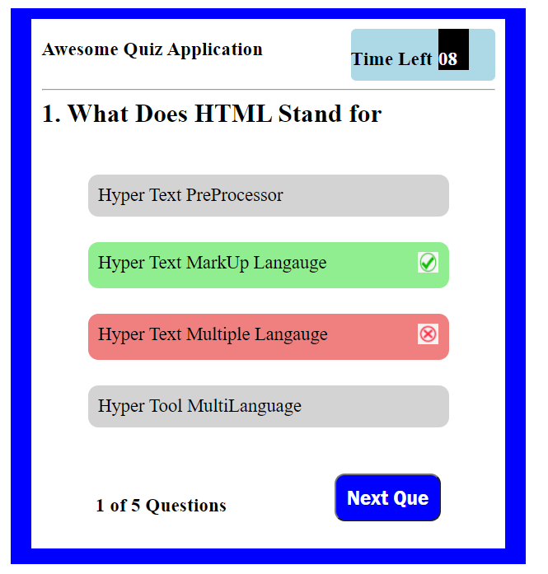

6 Create the following design using HTML and CSS.
<!DOCTYPE html>
<html>
<head>
<!-- <link rel="stylesheet" href="style6.css"> -->
<style>
.main{
width: 650px;
height: 100px;
display: flex;
justify-content: space-around;
background-color: blue;
color: white;
position: absolute ;
border-radius: 10px;
margin-left: 300px;
margin-top:10px ;

}
.col2{
padding-top: 20px;
/* border-radius: 10px; */

}
button{
background-color:blue;
border-color: white;
border-width: 2px;
border-radius: 10px;
width: 100px;
color: white ;

}
</style>
</head>
<body>
<div class="main">
<div class="col1">
<h3>call to action! It is time</h3>
<h4>Sign up our product by clicking the button wirght over there</h4>
</div>
<div class="col2">
<button><h3>Sign Up</h3></button>

</div>
</div>

</body>
</html>

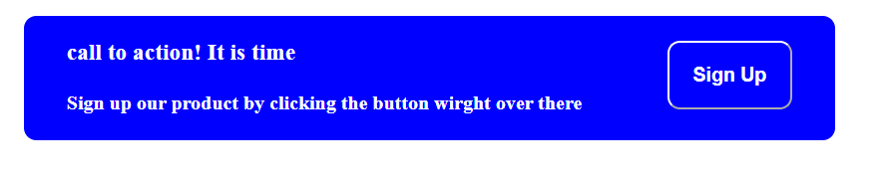

7. Create the following design using HTML and CSS. Note: You can use any values of your choice for sizes of texts or the (inner) containers but the overall look should be similar.
<!DOCTYPE html>
<html>
<head>
<!-- <link rel="stylesheet" href="style7.css"> -->
<style>
.main{
width: 100%;
height: 500;
background-color: rgb(17, 17, 41);
color: aliceblue;
}
.navbar{
display: flex;
justify-content: space-around;
/* justify-content: center; */
}
.col2{
display: flex;
justify-content: ;
}
ul li{
display: inline;
margin-left:40px ;
font-size: 20px;
}
.bod{
display: flex;
margin-left: 300px;
/* margin-right: 200px; */
height: 300px;
width: 600px;

}
.bcol1{
/* background-color:blue; */
height: 200PX;
width: 400PX;

}
.bcol2{
background-color: rgb(104, 101, 101);
height: 100PX;
width: 300PX;
margin-top: 25px;
text-align: center;
display: flex;
align-items: center;
padding-left: 20px;
margin-left: 10px;

}
button{

background-color:rgb(39, 39, 216);
border-color: white;
border-width: 2px;
border-radius: 5px;
width: 70px;
color: white ;
padding: 5px;

}
</style>
</head>
<body>
<div class="main">
<div class="navbar">
<div class="col1">
<h2>Header Logo</h2>
</div>
<div class="col2">
<ul>
<li>Link 1</li>
<li>Link 2</li>
<li>Link 3</li>

</ul>

</div>
</div>
<div class="bod">
<div class="bcol1">
<div class="tit">
<h2>This website is Awesome</h2>
</div>
<div class="para">
<p>
This website has some subtext that goes here under the main
title. It's smaller font and the color is lower constrast
</p>
</div>
<div class="but">
<button> Sign Up</button>
</div>
</div>
<div class="bcol2">
<p>This is place holder for image</p>
</div>
</div>
</div>
</body>
</html>

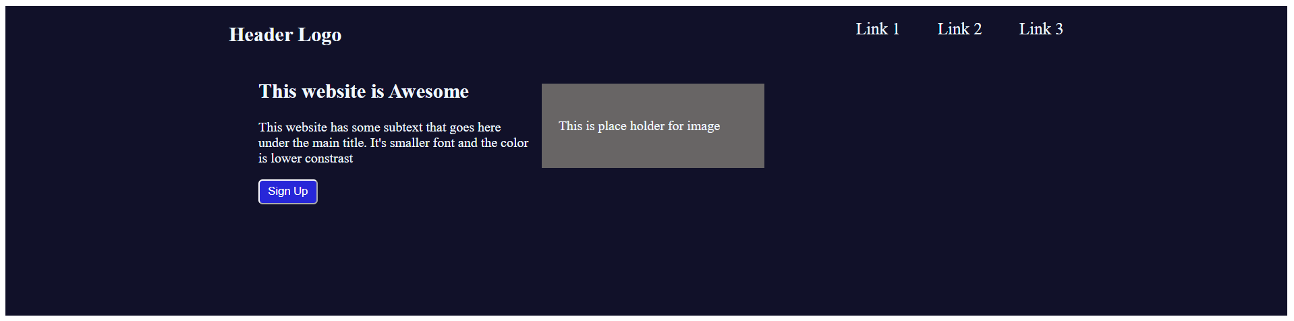

8.
<!DOCTYPE html>
<html>
<head>
<style>
tr:nth-child(2n){
background-color: gray;
}
tr:hover{
background-color: lightpink;
}
td{
padding: 10px;
}
table{
margin-left: 300px;
width: 700px;
}
</style>
</head>
<body>
<table cellspacing="2px" border="1">
<tr style="background-color: rgb(17, 13, 13);color: white;">
<td>
col 1 heading
</td>
<td>
col 2 heading
</td>
<td>
col 3 heading
</td>
<td>
col 4 heading
</td>

</tr>
<tr>
<td>
row 2 col1
</td>
<td>
row 2 col2
</td>
<td>
row 2 col1
</td>
<td>
row 2 col1
</td>

</tr>
<tr>
<td>
row 2 col1
</td>
<td>
row 2 col1
</td>
<td>
row 2 col1
</td>
<td>
row 2 col1
</td>

</tr>
<tr>
<td>
row 2 col1
</td>
<td>
row 2 col1
</td>
<td>
row 2 col1
</td>
<td>
row 2 col1
</td>

</tr>
<tr>
<td>
row 2 col1
</td>
<td>
row 2 col1
</td>
<td>
row 2 col1 </td>
<td>
row 2 col1
</td>

</tr>

</table>
</body>
</html>

